PROJECT OVERVIEW STATEMENT  The goal is to create an agent-based digital twin framework that will use machine learning and generative modeling approaches to continually monitor, forecast, and explain frozen fruit quality decline | Project Name: An Agent-Based Digital Twin Framework for Predicting and Early Detection of Decreasing Frozen Fruit Quality |  | Student Name: Alekya Koppaka , Padmaja Preksha Dinesh,Tripsy Bhaveshbhai Kheni
Problem/Opportunity:
An Agent-Based Digital Twin Framework for Predicting and Early Detection of Decreasing Frozen Fruit Quality

Since most degradation processes take place internally and gradually over time, it might be challenging to detect frozen fruit quality decline during cold-chain storage in its early stages. Existing inspection techniques, which frequently fall short in identifying early degradation trends, depend on surface-level observation or recurring laboratory testing.

There is a chance to create a data-driven digital twin system that uses predictive modelling and multimodal information to continuously check the quality of frozen fruit. Early internal degradation detection, forecasting under various cold-chain conditions, and reactive cold-chain management decision-making would all be made possible by such a system.
Goal:
To design and implement an agent-based digital twin framework that integrates multimodal frozen fruit datasets and applies machine learning and generative modeling techniques to monitor, forecast, and explain quality degradation during cold-chain storage within an 11-week timeline.

SMART Criteria:
Specific: Develop a functional digital twin prototype modeling fruit quality dynamically.
Measurable: Achieve ≥85% predictive performance (accuracy or acceptable RMSE).
Assignable: Designed and implemented by the student.
Realistic: Built using publicly available datasets and ML frameworks.
Time-related: Completed within 11 weeks.
Objectives:
- Objective 1: CNN-Based Model for Classifying Images
- Result: A convolutional neural network (CNN) model that can distinguish between three types of frozen fruit quality fresh, slightly deteriorated, and spoiled should be developed.
- Time Frame: 1-2 weeks
- Measure: At least 80% classification accuracy on validation data with respectable F1-score, precision, and recall should be obtained.
- Action: By gathering publicly accessible fruit image datasets, preprocessing and enhancing the photos, putting a transfer learning CNN model into practice with PyTorch or TensorFlow, training the model, and assessing its effectiveness with common classification metrics.

- Objective 2: Model for Predicting Time-Series Degradation
- Result: Create a time-series machine learning model that can forecast future deterioration of fruit quality by utilizing environmental data, storage time, and temperature.
- Time Frame: 3-5 weeks
- Measure: Attain steady degradation trend forecasting accuracy and satisfactory predictive performance as determined by RMSE (Root Mean Square Error) or MAE.
- Action: To forecast deterioration levels over time, preprocess sensor information, conduct exploratory data analysis, create relevant features, and use regression or LSTM-based models.

- Objective 3: Representing Digital Twins
- Result: Construct a single dynamic quality state by integrating the outputs of both image-based and sensor-based models into a single unified latent quality representation, or digital twin.
- Time Frame: 6-8 weeks
- Measure: Show enhanced predictive stability and integrated performance over separate models, as confirmed by a combination of evaluation indicators.
- Action: By combining CNN embeddings and time-series outputs using feature fusion approaches to create a single latent representation that dynamically evolves in response to current inputs.

- Objective 4: The Module for Agent-Based Decision Making
- Goal: Create an intelligent decision module that uses anticipated deterioration risk to produce actionable storage recommendations and early warning warnings.
- Time Frame: After integrating the digital twin, it must be finished within two weeks.
- Measure: By simulated cold-chain scenarios, automated alarms are successfully generated when degradation risk above thresholds has been reached.
- Action: develop and set down machine learning-driven decision logic that continuously checks the outputs of digital twins and generates suggestions for storage optimization.

- Objective 5: Creating Dashboards and Integrating
- Goal: Working with dashboard interface that shows generated alarms, degradation projections, and real-time quality classification.
- Time Frame: Within the last two weeks of the project timeframe, this must be finished before the final project is submitted.
- Measure: A successful demonstration of an operational end-to-end system pipeline that shows precise forecasts and notifications on an interactive dashboard.
- Take action: By integrating all produced modules into a single interface and document the full research process.

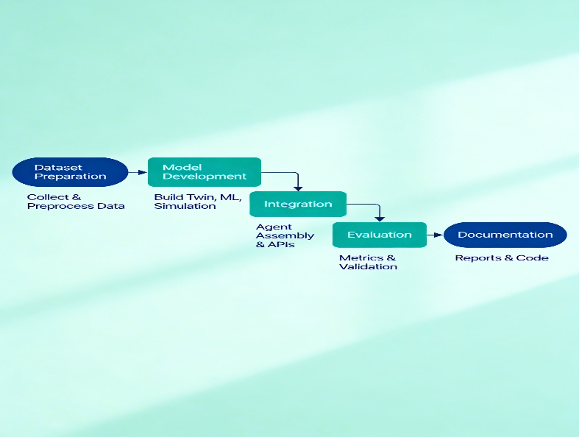
Image. 1 Flowchart
Success Criteria:
The project's end product will be an agent-based digital twin system that can track the quality of frozen fruit over time and forecast when it will deteriorate. In particular, the system will:
- Assess Current Quality: To identify early-stage, undetectable degradation in frozen fruits, use sensor data and photos to ascertain the latent quality condition.
- Future Quality Prediction: Use generative models to estimate how fruit quality will alter under various storage circumstances (such as temperature shifts, extended storage, and freezing and melting cycles).
- Provide Actionable Insights: Produce alerts and suggestions for logistics teams that are readable by humans, such as which batches are susceptible to spoiling or when action is required.
- Minimize Waste and Optimize Cold Chain: The system will increase overall efficiency, and reduce food waste by facilitating early detection and predictive decision-making
Assumptions, Risks, Obstacles:
Assumptions:
- For this project, it is assumed that the selected datasets contain meaningful quality-related attributes such as temperature variations, storage duration, physicochemical indicators, or other measurable factors that reflect frozen fruit degradation. It is also assumed that the data is sufficiently structured and consistent to support machine learning model development without requiring extensive reconstruction.
- Another assumption is that historical data patterns are reliable enough to allow predictive modeling and forecasting. In addition, it is assumed that the available computational resources and software tools will be adequate for training and validating the proposed models within the project timeline.

Risks:
- The chance for noisy, inconsistent, or incomplete data is one of the major concerns since it could have a negative impact on the dependability and performance of the model. Prediction accuracy may suffer if significant degradation indications are absent or inadequately documented.
- The integration of multimodal data presents an additional danger. Combining several data types like environmental readings and quality indicators may make things more complicated technically and necessitate more preprocessing and alignment work.
- Another concern is time limits. Unexpected technical difficulties, particularly in generative modelling or digital twin architectural design, could impede progress because the project has a tight deadline.
Obstacles:
- Possibility is unbalanced data. The algorithm may have difficulty recognizing initial damage if the dataset contains an excessive number of normal-quality samples relative to degraded samples.
- Training complex generative or machine learning models may provide computational challenges, especially if the dataset is big or requires high-dimensional processing.

Prepared By | Date | Approved By |  | Date
Alekya Koppaka  Padmaja Preksha Dinesh,  Tripsy Bhaveshbhai Kheni | 2/10/2026

